Adaptive radiotherapy planning via deep reinforcement learning: a physics-informed beam optimization agent (head and neck cancer, OpenKBP dataset)

Project Definition

Idea
The project builds a reinforcement learning agent that learns to control the intensity of nine radiation beams — fraction by fraction, across a 35-step treatment course — for head and neck cancer patients. Rather than producing a single static treatment plan (as all current clinical systems and published OpenKBP solutions do), the agent adapts its beam weights at every fraction based on the cumulative dose already delivered. It learns this adaptive policy entirely from a reward signal derived from real medical physics, computed via a pre-calculated Dose Influence Matrix (DIM) from the pyRadPlan engine.

Goal
To train an agent whose final 35-fraction cumulative dose distribution matches or improves upon the clinical ground-truth plans in the OpenKBP dataset, measured by the standard DVH score and dose score metrics — while demonstrating genuinely adaptive behavior that no static planner can produce.

What makes it original
Every published OpenKBP solution is a supervised regression model that predicts the full-course dose in a single forward pass. This project is the first to frame OpenKBP as a sequential decision problem, where the agent must learn a temporal policy under cumulative OAR toxicity constraints. The DIM-based physics engine enables this at millisecond-per-step speed, making RL training tractable.

Required tools & dataset
Component | Tool
Dataset | OpenKBP (340 head-and-neck patients, CT + masks + ground truth dose)
Physics engine | pyRadPlan — computes DIM from CT and structure masks
Medical image I/O | SimpleITK — loads and resamples DICOM/numpy volumes
RL environment API | Gymnasium — custom TreatmentPlanningEnv class
RL algorithms | Stable-Baselines3 — PPO (primary), SAC (continuous baseline)
Surrogate fallback | RTDosePrediction DCNN (pretrained weights) — if pyRadPlan proves unstable
Evaluation | OpenKBP official scoring scripts — DVH score + dose score
Training compute | Single GPU (Colab Pro A100 or equivalent)

Parameter | Detailed defenition
State (S) | 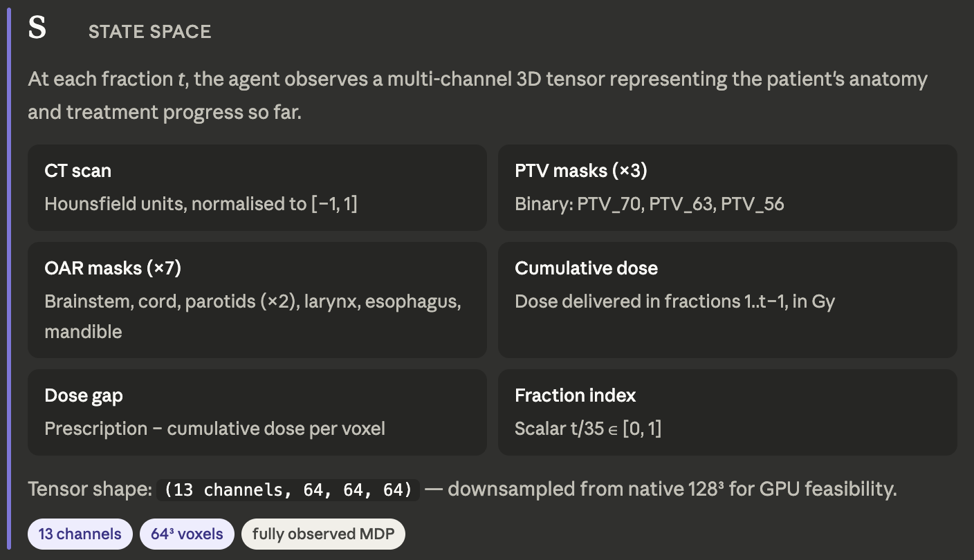
Action (A) | 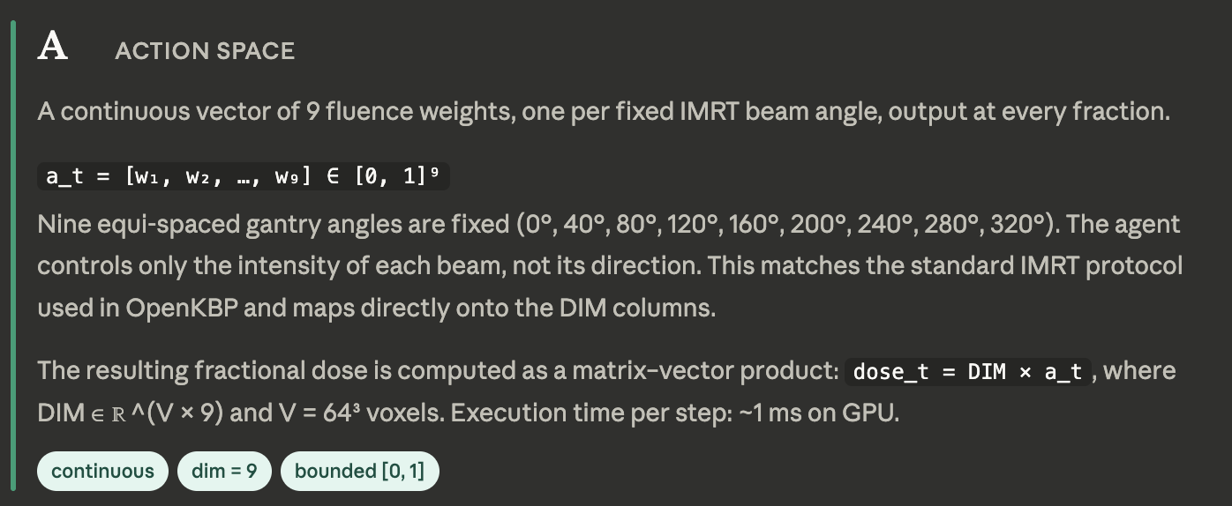
Reward (R) | 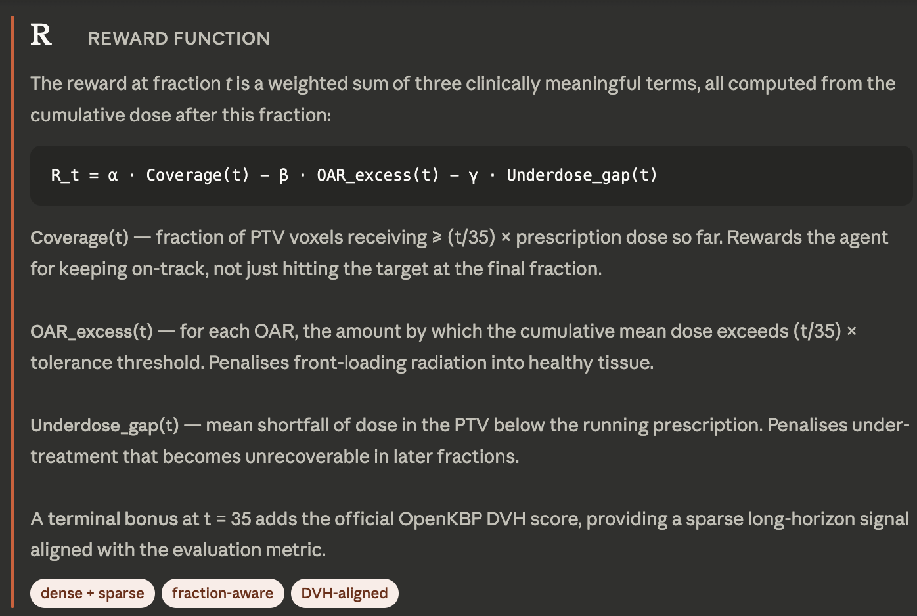
Discount Factor (γ) | 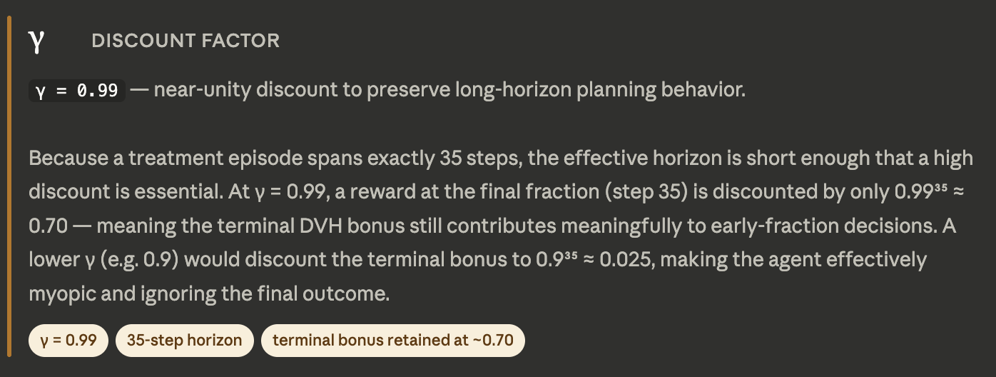
Policy (π) | 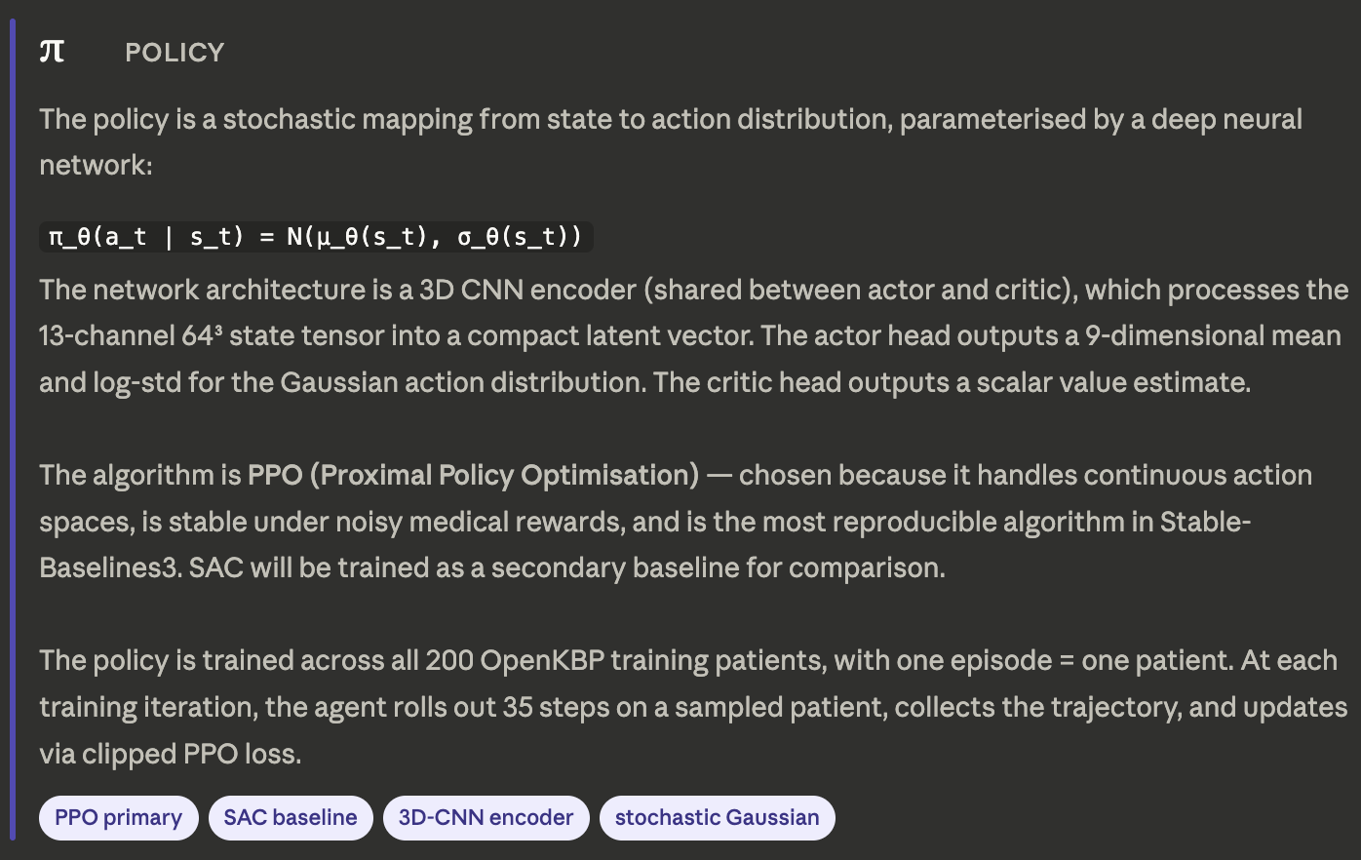
Exploration vs. Exploitation | 